# Earth Quake Prediction and Analysis by using python

Phase-1 Document Submission

Project: Earth Quake Prediction

Abstract :

An earthquake is shaking of the surface of the Earth, which caused as the result of movable plate boundary interactions .Earthquakes are measured using remarks from seismometers with Richter magnitude scale. Ground rupture, Landslides, Soil liquefaction and Tsunami are the main effects created by earthquakes. Today's earthquake warning systems used to provide regional notification of an earthquake in progress. Many methods have been already developed for predicting the time and place in which earthquakes will occur, but it did not predicted using big data analytics. This journal know that the Standard Deviation to identify next earthquake happening from tons of international geological survey data using data analysis in pandas & matplotlib framework. It's the top-level component of all the ones that you will consider in the following point current location shakes per minute. Other than above mentioned features separate pandas and matplot function implemented to analyze sheer number of earthquakes per day. Final result shows which location suffered from maximum number of shakes and priority of earthquake occurrence location and Time.

Keywords :

Earthquake, Seismic waves, Seismometer, Richter magnitude scale, Tsunami, Earthquake warning systems, Big Data, Map Reduce.

I. INTRODUCTION

Today, big data analytics is one of the most booming markets. When Google search engine launched image search feature, it had indexed more than 300 million images. In every minute so many video content are uploaded in YouTube update their wall in every minute. Search engines logging 600 million queries daily. There are different data centers where people can store vast amount of data, such as IBM Server, EMC Server etc. On the other hand AWS (Amazon Web Services) provide a host of services to store, process and analyze the data at scale in a cost effective manner. Big data term refers collection of large datasets that are distributed, multidimensional and complex that it becomes difficult to processing on hand traditional data processing applications.

II. EXISTING SYSTEM

The existing system addresses novel methodology to predict next earthquake. Apache hadoop is designed to run in a distributed environment and it manages the collection of various nodes running map and reduce function. In this system data analysis performed on earthquake data in year wise and location wise. The result indicates that next possible earthquake location identified correctly. The exisiting system Mapper and Reducer class applicable any U.S. geological earthquake survey data.in this funcation some drawbacks in data handaled but pandas overcome the problems thats way using pands & matplotlib frame work reduse the problem and predict the possible output.

Earthquakes have always caused incalculable damage to structures and properties and caused the deaths of millions of people throughout the world. In order to minimize the impact of such an event, several national, international and transnational organizations take various disaster detection and prevention measures. Time and quantity of the organization’s resources are limiting factors, and organization managers face several difficulties when it comes to the distribution of the resources. Leveraging the power of machine learning is a viable option to predict the degree of damage that is done to buildings post an earthquake. It can help identify safe and unsafe buildings which helps to predict damage prone areas and thus avoiding death and injuries resulting from the aftershock of an earthquake, while simultaneously making rescue efforts efficient. This is done by classifying these structures on a damage grade scale based on various factors like its age, foundation, number of floors, material used and several other parameters. Then the number of families and the probable casualties ward-by-ward in a district are taken into account. This enables distribution of relief forces proportionately ward-wise and its prioritization based on the extent of damage. Models of this kind can help save as many lives as quickly as possible and turn out to be an efficient and costeffective solution. It can be further improved by the inclusion of distribution of resources like food, clothes, medical, monetary supplies based on the extent of human casualties and the damage incurred by the various structures. The main disadvantage of the existing system is highly expensive. And the portability of the Device is very difficult. The Existing system using only converts using modules county and number of earth quakes only provided. The dataset was found to have a total of 1,038,900 records, with the number of records in the test dataset being 421,175. while that of the train dataset was 617,725. The training data and the test data percentages has been observed to be 70.50% and 50.50% (approximated to80% and 60% respectively)

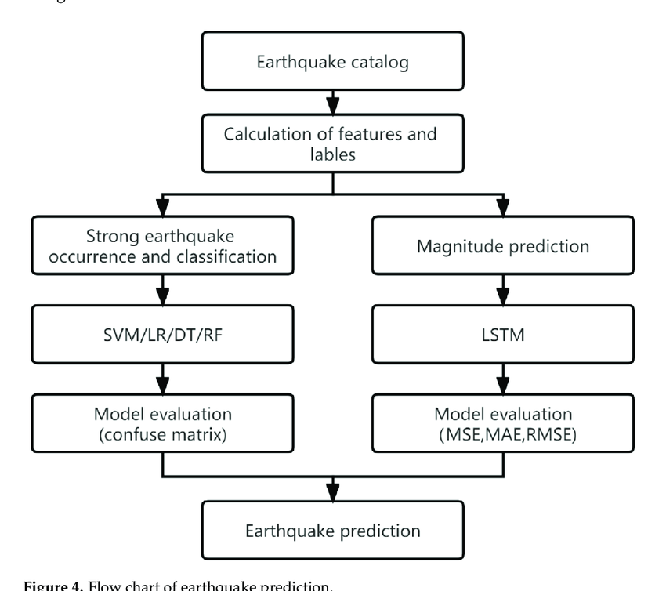

III. PROPOSED SYSTEM

In future, same Mapper and Reducer class implemented with pandas and matplatlib frame work components working effactive manner. Pandas handale with a data is esay that’s way proposed system run with effactively. visuvalation method is matplatlip framework working with overcome the exsisting system. data parsing &data format conversion is esay way to possible in pandas. Given query and get final result in graphically. The graphs compare the number of affected buildings (count) for a particular Damage Grade to their corresponding foundation type, roof type and ground floor type respectively. The ratios indicate the likelihood of buildings with the given material’s ability to sustain damage against earthquakes. The ratios are considered here instead of directly comparing the number of affected buildings as the former can take into account the variation observed among the Damage Grades in each case, irrespective of the number of affected buildings . A lot of research is being done in this field, as a result of which manifold approaches to predict damage on account of earthquakes have been worked upon and developed.

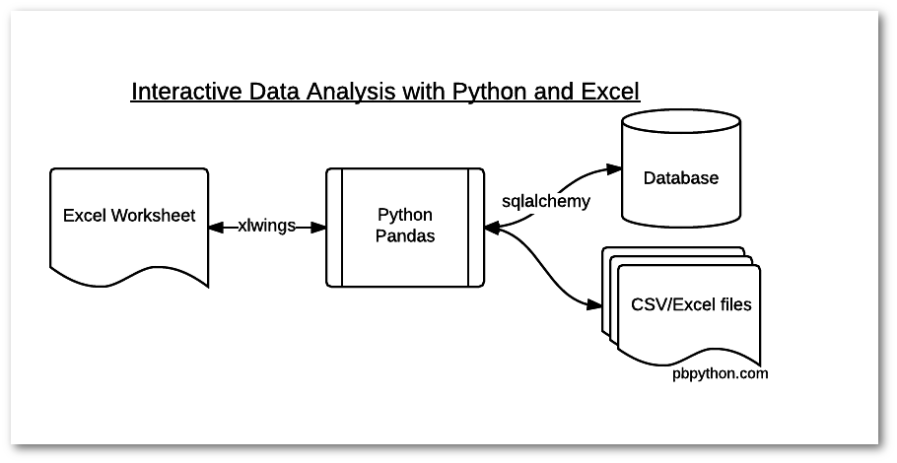

This is the block diagram of the Web Reader Application. This diagram shows the flow of the Web Reader Application. The user can give the prefixed URL input to the Web Reader Application. And the python libraries like requests, bs4, textblob are processed the URL and retrieve the specified web content from the given particular URL.

IV. DESIGN AND IMPLEMENTATION

This covers the technique and flow of events that were used to perform the prediction process. The prediction methodology itself is composed of three integral steps: data preprocessing, model selection and the final prediction process. In the dataset, a building was uniquely identified by 4 attributes: Building Identification, District Identification, Municipality Identification, Ward Identification. These attributes were added to the training data for identifying the building damage grade. There were 33,417 entries in the attribute pertaining to whether building repairs on earthquake affected buildings had started or not, that were found to be blank. Based on the assumption that since there was no formally documented record of the commencement of the repairs, the blank values were assumed to be not repaired. Such filling was done on the basis of the worst case scenarios possible to get optimal results. The models developed by the individual algorithms were trained on the training dataset and then test data was used for final prediction of damage grades and for evaluation. Since on evaluation, Random Forest Classifier algorithm was found to possess the highest F1 score, the model was considered for the prediction process. On dropping the following Boolean attributes from the dataset we found an increase in the model score from 0.75127 to 0.76503 – whether the building has secondary use as an institution, whether the building has other geotechnical risks

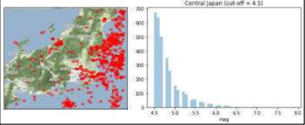

The python library matplotlib, pandas, os are used in our project. The detailed explation of each library is followed by

1) pandas— pandas library is a fast, powerful, flexible and easy to use open source data analysis and manipulation tool, built on top of the Python programming language. In computer programming, pandas is a software library written for the Python programming language for data manipulation and analysis. In particular, it offers data structures and operations for manipulating numerical tables and time series.

2) Matplotlib---- Matplotlib is a comprehensive library for creating static, animated, and interactive visualizations in Python. Matplotlib makes easy things easy and hard things possible. Create. Develop publication quality plots with just a few lines of code. Use interactive figures that can zoom, pan update.

3) Matplotlib is a plotting library for the Python programming language and its numerical mathematics extension NumPy. It provides an objectoriented API for embedding plots into applications using general-purpose GUI toolkits like Tkinter, wxPython, Qt, or GTK+

4) numpy— NumPy is the fundamental package for scientific computing in Python NumPy arrays facilitate advanced mathematical and other types of operations on large numbers of data. Typically, such operations are executed more efficiently and with less code than is possible using Python's built-in sequences

5) pycharm— This is a Professional feature download PyCharm Professional to try. In this tutorial, you operate in Scientific Mode and use Matplotlib and NumPy packages to run and debug a Python code with data visualization. Before you start, ensure the following is installed Conda interpreter. Matplotlib package

6) OS— The OS module in Python provides a way of using operating system dependent functionality. The functions that the OS module provides allows you to interface with the underlying operating system that Python is runningng on – be that Windows, Mac or Linux.

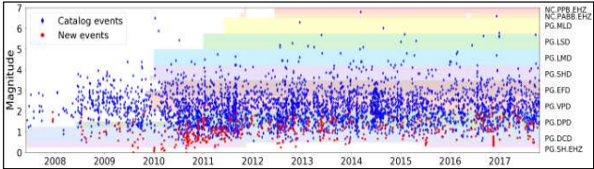

Sample python program for real time earthquake predictions:

import numpy as np

import pandas as pd

from sklearn.model_selection import train_test_split

from sklearn.svm import SVR

# Load the earthquake dataset

df = pd.read_csv('earthquake_dataset.csv')

# Split the dataset into training and test sets

X_train, X_test, y_train, y_test = train_test_split(df[['longitude', 'latitude', 'depth']], df['magnitude'], test_size=0.25)

# Create a support vector machine regressor

regressor = SVR()

# Train the model on the training set

regressor.fit(X_train, y_train)

# Make predictions on the test set

y_pred = regressor.predict(X_test)

# Evaluate the model performance

print('Mean squared error:', np.mean((y_pred - y_test)**2))

output:

